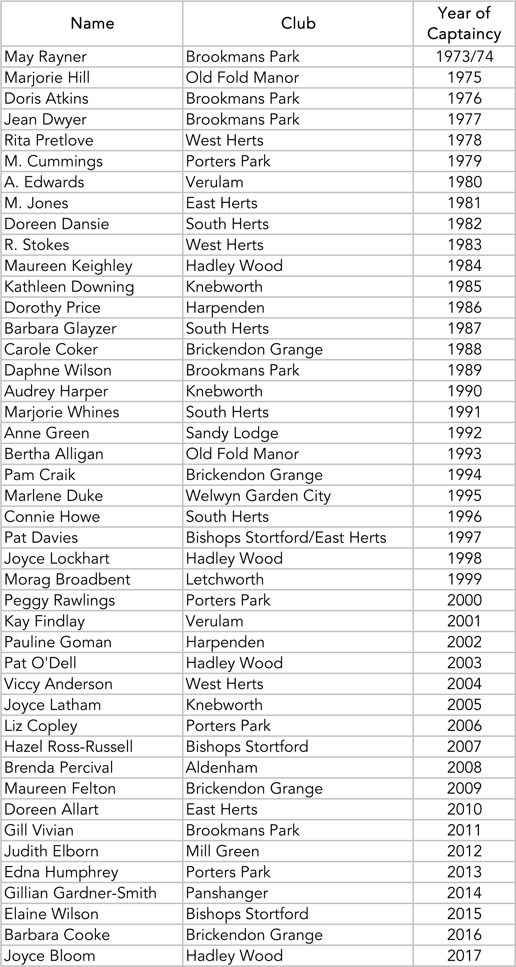
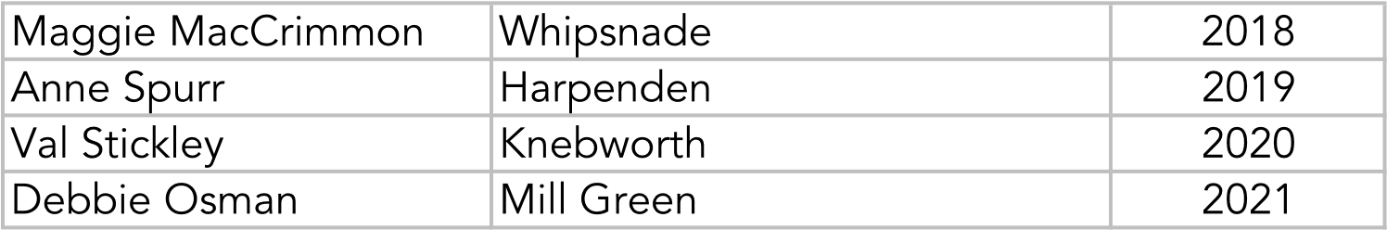
Sarah Brookes Letchworth 2022
Jackie Lagergren Hadley Wood 2023

